**Report Compiler Construction Lab**

Name: Hoàng Thanh Lâm

ID: 20194786

Result of running the scanner project with example2.kpl :

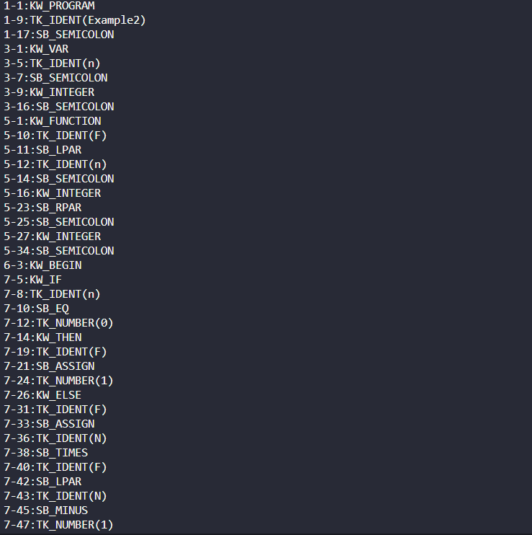

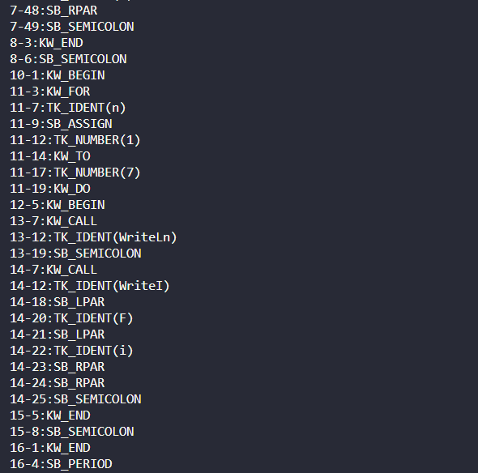

1. Case: ERR_ENDOFCOMMENT:

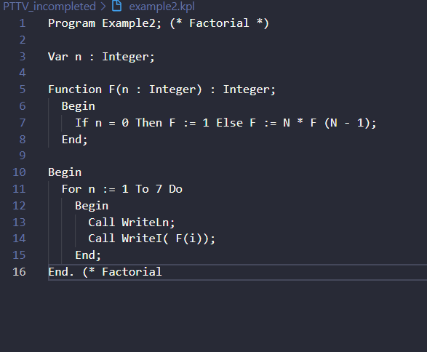

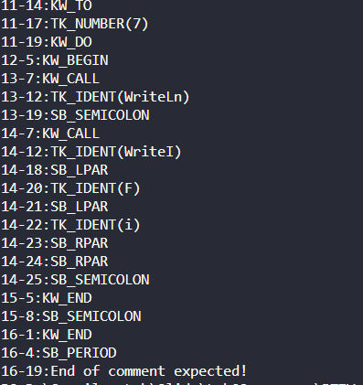

1. Case ERR_IDENTTOOLONG: 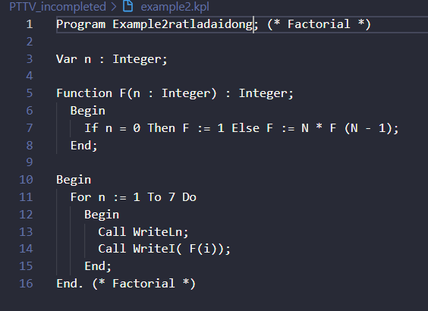
2. Case ERR_INVALIDCHARCONSTANT: 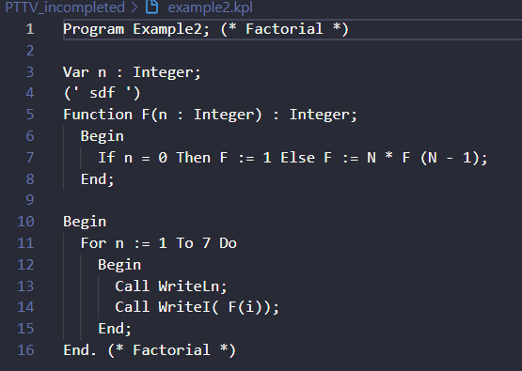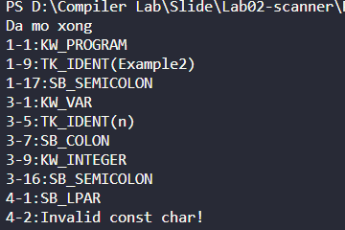
3. Case ERR_INVALIDSYMBOL:

